February 11, 2016

Dana Martin

Eggn 517

Modeling and Control of a limited degree of freedom single rotor helicopter

Contents

i. List of Figures 2

ii. List of Symbols 3

Part 1: Project Overview 4

Part 2: Modeling of the System 4

Part 2.1: System Definition 4

XXX References 9

Raw Figures 10

# List of Figures

Figure 1 - Vertical axis orientation w.r.t helicopter fuselage and main rotor

Figure 2 - Moment location and tail rotor thrust vector location

Figure 3 – Block diagram showing lift force dependencies and output

Figure 4 – Block diagram showing moment input output dependencies

# List of Symbols

β - Rotor blade flapping angle

ϴ - Rotor blade pitch angle

AM – Area of main rotor blade

rM – Radius of main rotor

aM – Lift coefficient slope for main rotor

FL - Aerodynamic lift force

ΩM – Main rotor rotational speed

AT – Area of tail rotor blade

rT – Radius of tail rotor blade

ΩT – Tail rotor rotational speed

DT – Horizontal distance from the main rotor to the tail rotor

M­F - Mass of helicopter fuselage

MB - Mass of main rotor blade

IB – Rotational inertia of main rotor blade about the flapping axis

Z - Helicopter’s height from a reference point

- vertical velocity of the helicopter

R - Yaw position of a helicopter from a reference point

- Yaw rate of the helicopter

g – Gravitational constant (9.81 m/s2)

– Density of air at STP

# Part 1: Project Overview

A system is defined as interconnected components working together to accomplish a common goal. With the complexity of modern day technology increasing, systems are becoming more intricate with every new day. Often times, a whole team of multidisciplinary engineers are responsible for the design and implementation, with individual parts (or subsystems) being designed separately and implemented at a later date. This means that the knowledge and know-how of exactly how the system works is scattered throughout a large group of people from different backgrounds, so making sure the system functions properly, as well as at an optimum level, is also a difficult task.

The goal of this project is exactly that: Choose a system with multiple inputs and multiple outputs (MIMO) and design a state-space control system to control and optimize its function. There are many preliminary and intermediate steps encompassed in the design of a control system. For example: system definition, system modeling, control system selection, pole placements, control system performance, etc. which will all be investigated in sections to come.

# Part 2: Modeling of the System

## Part 2.1: System Definition

The initial step in the designing a controller is to define the system. In other words, what aspects can be controlled, what aspects will be measured and how will they relate to one another. The system of interest is a double rotor helicopter with limited degrees of freedom (DOF) in hover. The main rotor will consist of two blades and have a fixed angular velocity with varying pitch and flapping angles. The tail rotor will be a fixed pitch, zero flapping angle, and will have a varying angular velocity. The helicopter will be free to move in vertical direction (denoted by Z) and rotate with a moment about the Z axis. This translates to the helicopter having freedom in the vertical direction and yaw movement (denoted by R).

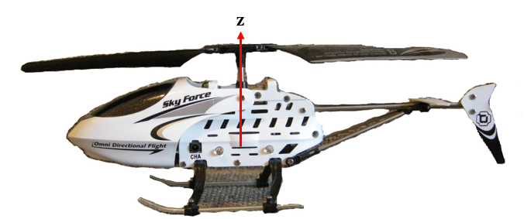

Figure 1-Vertical axis orientation with respect to helicopter fuselage

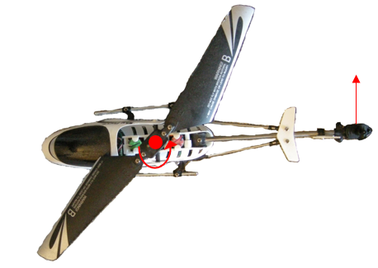

Figure 2-Top View of helicopter showing moment axis

From the above description, it can be seen that the state variables of interest are Z, $\dot{Z}$, $\ddot{Z}$, and R, $\dot{R}$, $\ddot{R}$. How will these “states” be controlled? For the main rotor, it will rotate at a constant angular velocity, and in order to change the aerodynamic lift force (FL) generated by the rotor the collective pitch (ϴ) and flapping angles (β) will be varied through small angles using actuators at the hub connection.

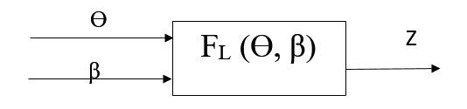

Figure 3-Lift force dependencies and output

Figure 1 above shows a how one of the state variables is related to the controlled input parameters. Since the rotor has a fixed rotational speed, the aerodynamic lift force must be varied by changing the pitch and/or flapping angle of the rotor. For simplicities sake, the lift coefficient (CL­) will be assumed to be two dimensional and constant. To calculate the relationship between the above input and output variables, free body diagrams are used to sum forces and moments in specified directions.

Summing the forces in the vertical direction, it can be shown that:

$\frac{I_{B}}{R}\ddot{β}+\frac{Ω_{M}^{2}\left(1+ε\right)}{R}β-M_{F}g=F_{L}$**Eq. 1**

Equation 1 assumes small flapping angles.

$\frac{I_{B}}{20R}\ddot{θ}+a_{M}θ\frac{1}{2}ρ_{air}{\left(Ω_{M}r_{M}\right)}^{2}A_{M}-M_{F}g=F_{L}$**Eq. 2**

Where,

$F_{L}=M_{F}\ddot{Z}$**Eq. 3**

The forces in the vertical direction have been analyzed and related to input parameters. Now the equations and inputs used to determine the yaw position of the helicopter will be developed. The tail rotor will be a constant pitch, variable speed rotor with zero flapping angle. It will be assumed that the flapping angle of the main rotor, β, will only be coupled with FL, while the pitch angle of the main rotor, ϴ, will be coupled with FL while also inducing a yawing moment that will have to be counteracted by the tail rotor, enacted at a distance DT from the main rotor. The yawing moment resulting from a change in the blades’ pitch angle is described by Equation 4 shown below.

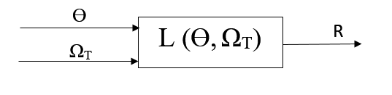

Figure 4-Block diagram showing moment relationship between inputs and outputs

$\frac{I_{B}}{20}\ddot{θ}+\frac{I_{B}}{20}Ω_{M}^{2}θ=L_{M}$**Eq. 4**

The yawing moment produced by the horizontal tail rotor thrust is described by Equation 5 shown below.

$\left(a_{T}θ_{T}\frac{1}{2}ρ_{air}{\left(Ω_{T}r_{T}\right)}^{2}A_{T}\right)D_{T}=L_{T}$**Eq. 5**

Through convention LM=-LT.

Therefore, the total moment on the helicopter fuselage is described by Equation 6.

$L_{T}-L_{M}=I_{F}\ddot{R}$**Eq. 6**

$$\left[\left(a_{T}θ_{T}\frac{1}{2}ρ_{air}{\left(Ω_{T}r_{T}\right)}^{2}A_{T}\right)D_{T}\right]-\left[\frac{I_{B}}{20}\ddot{θ}+\frac{I_{B}}{20}Ω_{M}^{2}θ\right]=I_{F}\ddot{R}$$

An overall block diagram representing the system described above is shown below.

using input variables that will be controlled, passing them through the “PLANT”, then measuring output parameters and comparing them to a desired value. Depending on whether or not the output has reached a desired value, the inputs will be adjusted until that state is reached.

The system of interest is a single rotor helicopter consisting of a 2 bladed rotor, and a fuselage. Because the dynamics and math behind helicopter flight is highly complicated, the simplified system will consist of a fuselage with limited degrees of freedom. The fuselage’s center of gravity will be assumed to always be in line with the rotor shaft, allowed to move in the vertical direction (denoted by **Z**) and yaw about the z-axis. In order to balance the yaw, a tail rotor will exert a horizontal force counteracting the moment enacted by the main rotor. The state variables of interest are z, $\dot{z}$, r, $\dot{r}$

Z=helicopter’s height from some reference point

$\dot{Z}$ =vertical velocity of the helicopter

R=yaw position of a helicopter from a reference point

$\dot{R}$ =Yaw rate of the helicopter

The tail rotor is a fixed pitch rotor with a varying rotational velocity, while the main rotor is varying pitch, varying cone angle, fixed rotational velocity. In order to counteract the yawing moment, the tail rotor’s angular velocity will be controlled, and to control the height of the helicopter the pitch or flapping angle will be varied.

In order to develop a mathematical model of a single rotor helicopter (at least one which is within the scope of this class) quite a few assumptions must be made:

* The lift curve slope is assumed to be two dimensional and constant
* The fluid (air) is assumed to be incompressible
* Stall and reversed flow effects are ignored
* The induced velocity distribution, normal to the rotor disc, includes linear longitudinal and lateral variations, the value at the center satisfying simple momentum considerations.
* Coupling from blade pitch and lag dynamics into flapping motion are ignored
* Quasi-steady flapping and coning are used in the derivation of the reaction forces and moments on the fuselage. i.e. the interaction of disc tilt modes with fuselage mode are neglected.

Controlling a helicopter is a complicated and intricate task, with a total of 6 degrees of freedom encompassing linear movement in the x,y and z directions along with roll, pitch and yaw movements.

For the sake of time and scope of, not all of the degrees of freedom will be included in the control system, and **model of a helicopter in hovering is considered**. A simplified block diagram of the Plant is shown below with inputs shown coming in from the left, and outputs leaving to the right.

**Inputs**

$M_{a}$

­

PLANT

β

L­

ϴ

D

N­

**Outputs**

Where:

M­a=Moment about the flapping axis

L=Moment about the pitching axis

N=Moment applied to balance pitching moment

D=A disturbance correlated to a change in mass of the system

β=Flapping position

ϴ=Pitch position

Another important aspect in the preliminary stages of designing a controller is to determine the equations that relate the inputs to the outputs, or the “PLANT”. For the simplified model of the helicopter (or the PLANT), the equations relating the input to the output are as follows [3]:

$\ddot{β}+Ω^{2}\left(1+ε\right)β={M_{A}}/B$**(1)**

$$Ω-Rotational Speed of rotor$$

$$ε-material property of blade. A typical value of ε is 0.06 [3]$$

$$B-Rotational Inertia about the flapping axis$$

$\ddot{θ}+Ω^{2}θ=L/A$**(2)**

L-Moment about pitching axis

$$A-Rotational Inertia abou the pitching axis$$

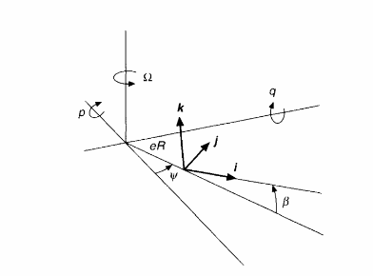

Figure 5-Blade coordinate system showing the flapping displacement [3]

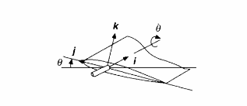

Figure 6-Blade Feathering diagram [3]

**Actuators and Sensors**

For inputs and outputs to change, and be controlled a way to convert mechanical energy to electrical energy and back to mechanical energy must be implemented, along with some way to measure the actuated objects. For the simplified system above, the above forces will be simply transmitted to the system with the characteristics, lag time, and ranges of specific actuators simulated with components in Simulink. To measure the performance of the system, a specified height and orientation will be fed into the control architecture and compared with the actual location.

**Conclusion**

Many intermediate equations will be needed to arrive at the final output values, but this is only a starting block with the inputs, outputs and main plant equations being the objects of focus. Depending on the ease and success of developing and controlling the above system, complexities and non-linearities may be added in the future in the form of more DOF or more complex disturbances.

# XXX References

1. Garcia,J.C., (1994). “Active Helicopter Rotor Control Using Blade-Mounted Actuators”.

Mechanical Engineering Department Massachusetts Institute of Technology.

1. Thanapalan, K.K.T, “Modeling of a Helicopter System”. Faculty of Engineering

Sciences, University College London

1. Bramwell, D.B., Bramwell’s Helicopter Dynamics. Pgs. 7-40. 2001

# Raw Figures

β

FL (β)

L (ϴ, ΩT)

ϴ

FL (ϴ)

ΩT

ϴ

L (ϴ, ΩT)

R

ΩT

ϴ

FL (ϴ, β)

Z

β

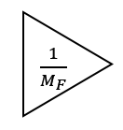

**z**

